NEW SUMMIT COLLEGE

**(Affiliated to Tribhuvan University)**



*Lab Report of*

**Geographical Information System**

**CSC 468**

*Bachelors of Computer Science and Information Technology Institute of Science and Technology*

**Submitted by: Submitted to:**

**Name: Manjul Sharma Lamichhane Instructor: Saugat Paudel Symbol No: 23433/076**

**Semester: VIII Program: BSc. CSIT**

***Lab Index: Open Access Quantum GIS (QGIS) Software***

|  |  |  |
| --- | --- | --- |
| ***SN*** | ***Title*** | ***Signature*** |
| **1** | Download and install Open Access Quantum GIS (QGIS) Software |  |
| **2** | Create vector layer of points, lines and polygons |  |
| **3** | Show the capital cities of each of the provinces and label them. |  |
| **4** | Import Shape Files of Provinces, Districts and Municipalities of Nepal |  |
| **5** | Mosaicking and Clipping |  |
| **6** | Geo-referencing Topo Sheet |  |
| **7** | Vector Analysis: How many buildings in Nepal have road access? |  |
| **8** | Vector Analysis: How many buildings are within a given district? |  |

***Practical 1: Download and install Open Access Quantum GIS (QGIS) Software***

1. Visit the website: <https://qgis.org/en/site/>
2. You will see the “Download Now” button as shown below. Click the button

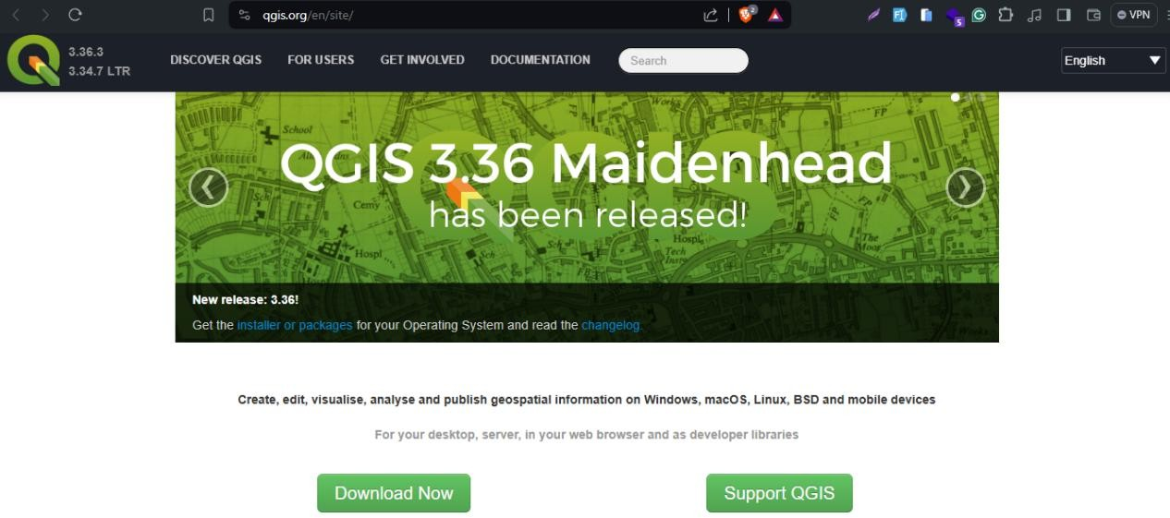

1. After you click, the software will begin downloading. It will take couple of minutes to around half an hour depending upon internet download speed.
2. After this, it is just like installing any other software. Just follow the instructions that comes in the screen (e.g. Next, Install etc.) and complete the installation.

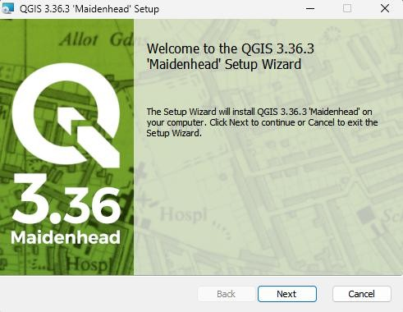

***Practical 2: Create vector layer of points, lines and polygons***

**Step 1:** Open QGIS and create a new blank project.

**Step 2:** Navigate to and click on the menu entry “Layer”, “Create Layer” and “New Shapefile Layer”.

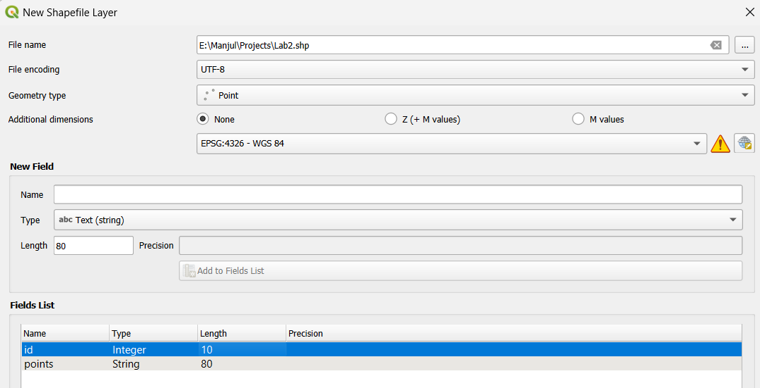

**Step 3:** Click … for the filename field. A save dialog will appear.

**Step 4:** For “Geometry Shape”, select “Polygon” from the drop down menu:

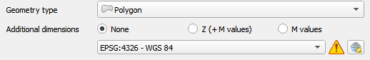

**Step 5:** Replicate the setup below, the click the “Add to Fields List” button.

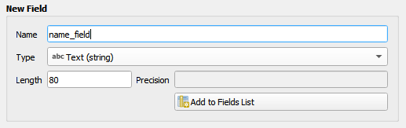

**Step 6:** Click OK.

**Step 7:** Replicate the same steps for Line. Finally the output is as shown below:

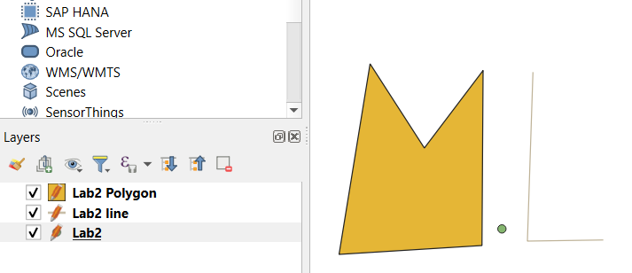

***Practical 3: Show the capital cities of each of the provinces and label them.***

**Step 1:** Download Administrative Map of Nepal from <https://nationalgeoportal.gov.np/>

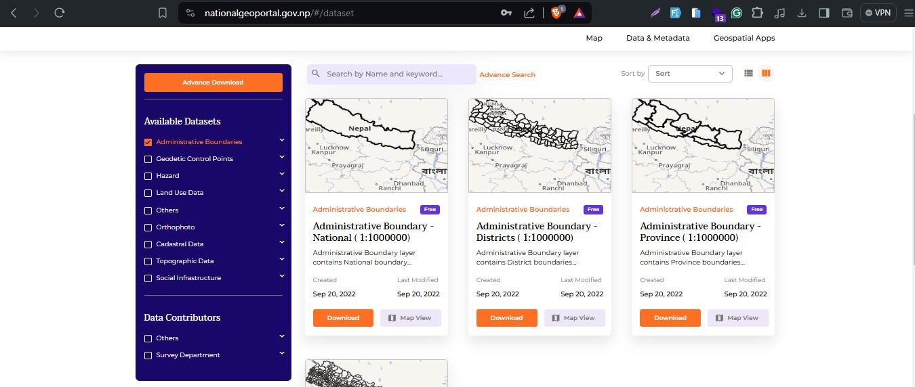

**Step 2:** Open the QGIS desktop. Double click on the “New Empty Project”.

**Step 3:** Click on “Data Source Manager”, then “Add Layer” and “Add Vector Layer”

**Step 4:** Locate the folder of shape files. Then click on “Add” button.

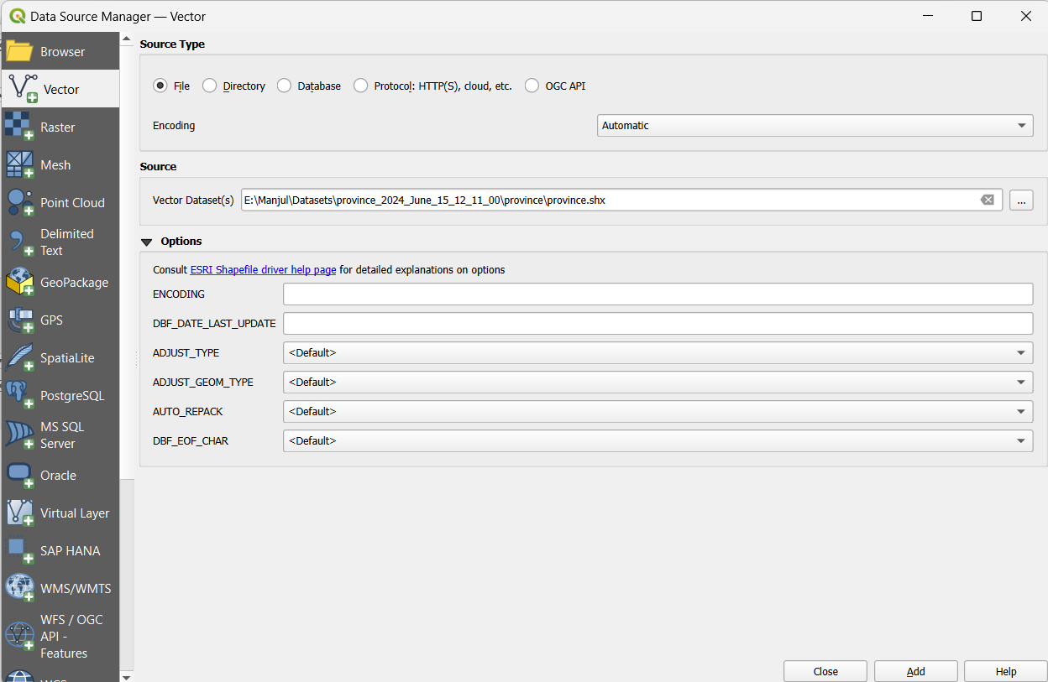

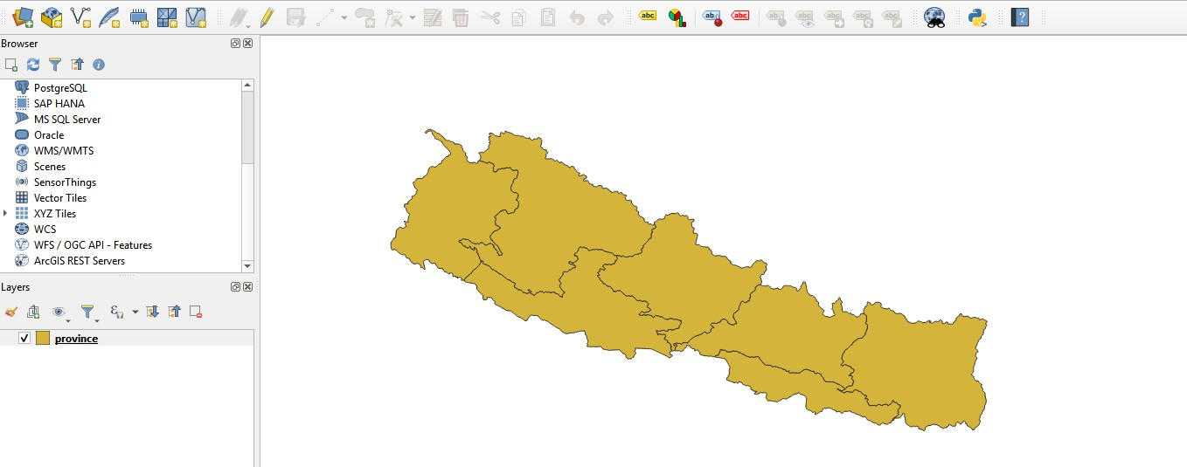

**Step 5:** Click on “Layer”, then “Add Layer” and “Add Delimited Text Layer”

**Step 6:** Select CSV file with coordinates and then click on Add.

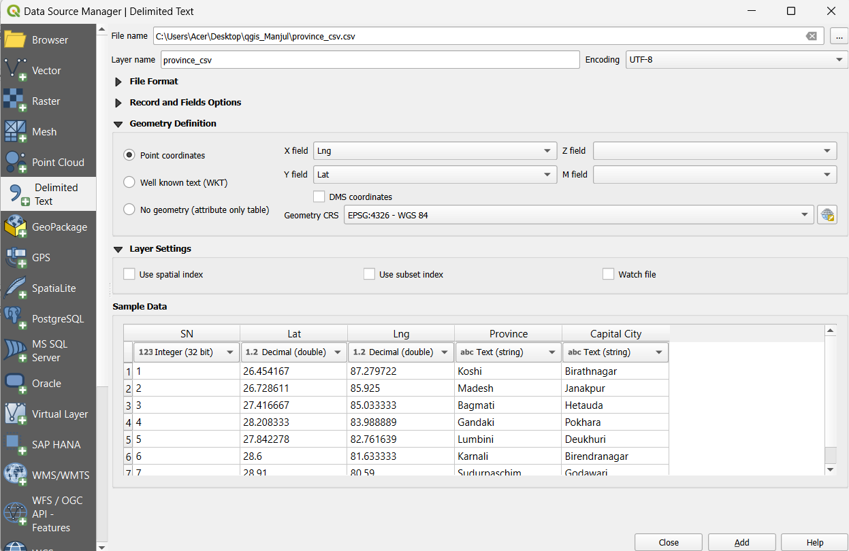

**Step 7:** Click on layer properties of CSV layer then on configure the labels option to display the name of the capital city then click on Apply.

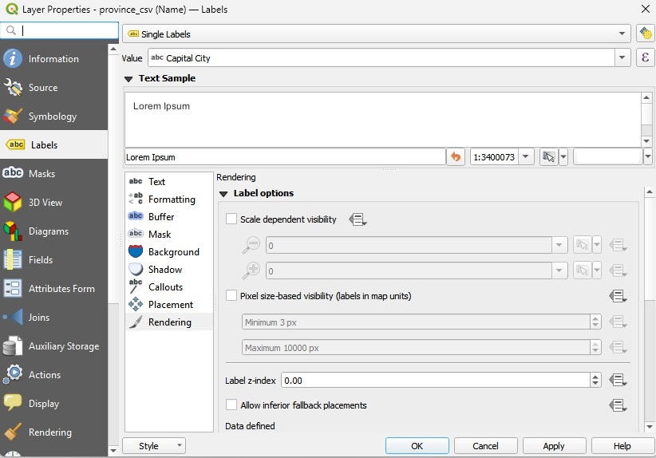

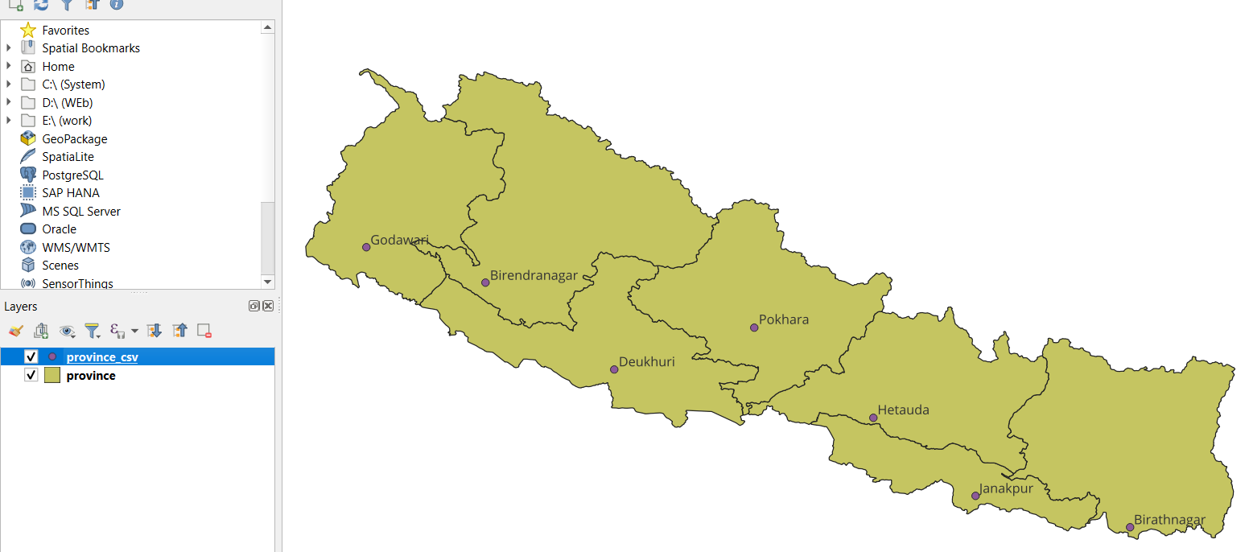

***Practical 4: Import Shape Files of Provinces, Districts and Municipalities of Nepal***

**Step 1:** Download Administrative Map of Nepal from <https://nationalgeoportal.gov.np/>



**Step 2:** Open the QGIS desktop. Double click on the “New Empty Project”.

**Step 3:** Click on “Data Source Manager”, then “Add Layer” and “Add Vector Layer”

**Step 4:** Locate the folder of shape files. Then click on “Add” button.

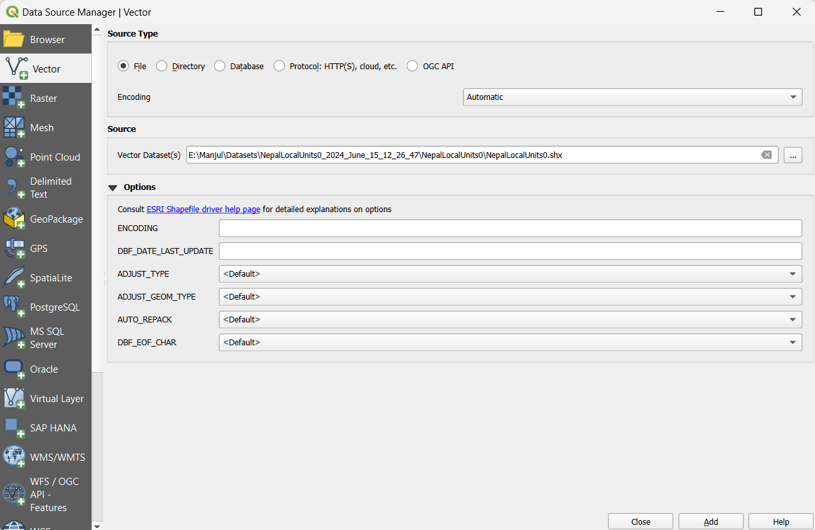

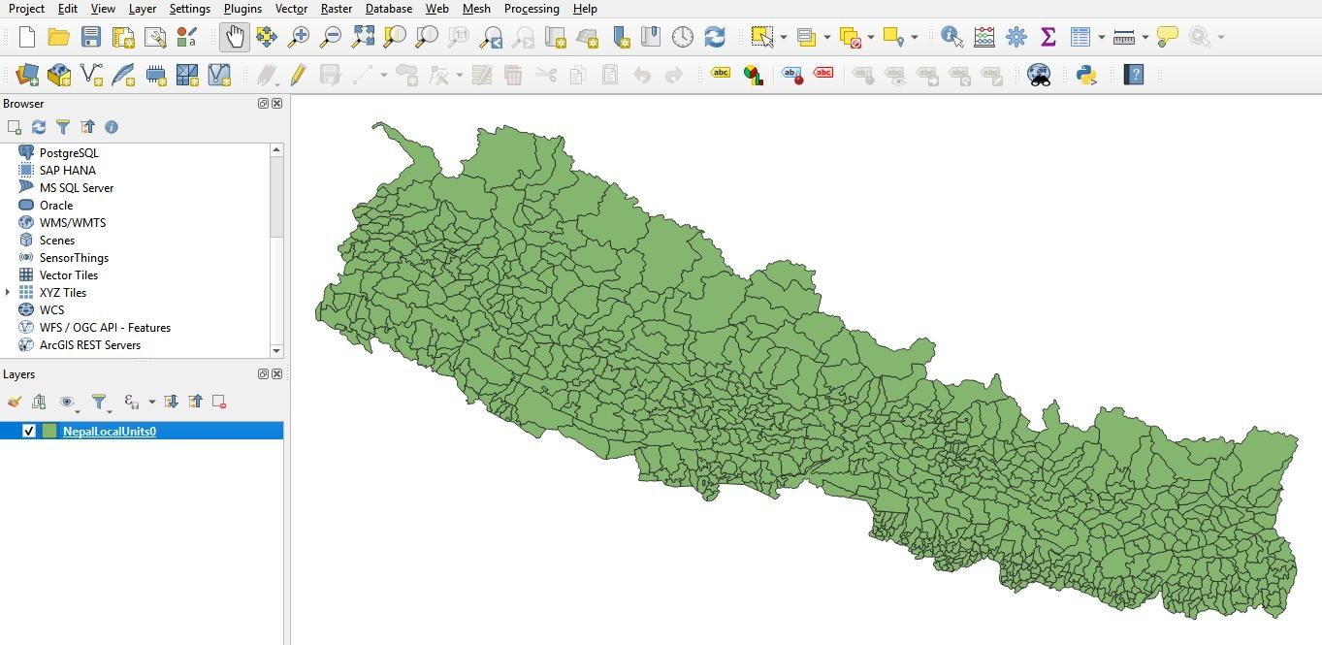

**Step 5:** Click on layer properties and find Symbology option and fill with transparent color and Upon clicking the “Apply” button, following output will be shown:

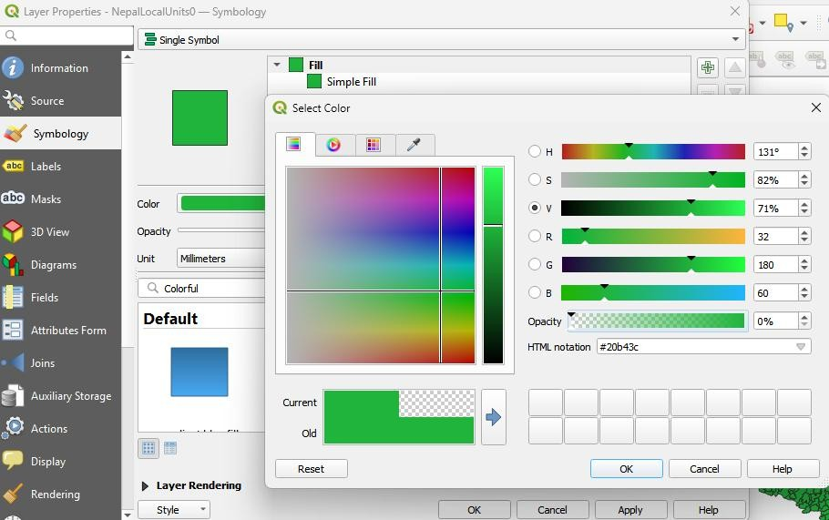

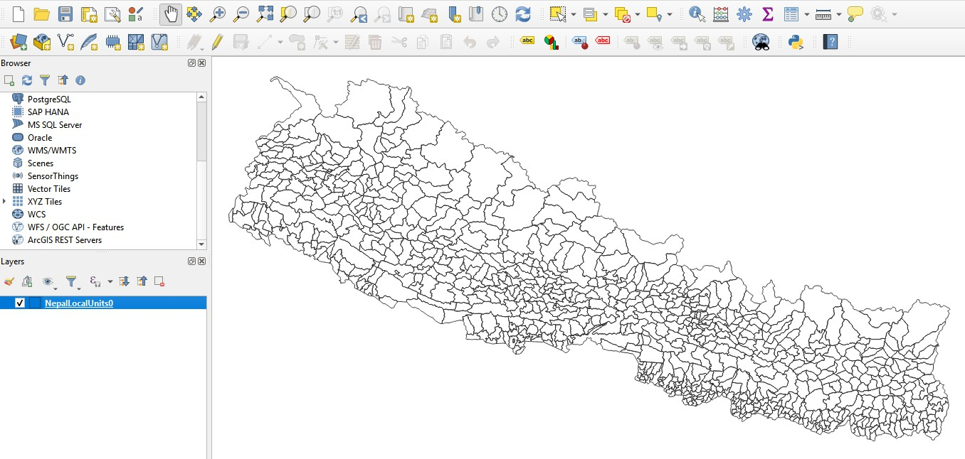

**Step 6:** On the “Processing Toolbox”. Search for “dissolve” under “Vector Geometry”. Click on “Dissolve” option and select dissolve by province.

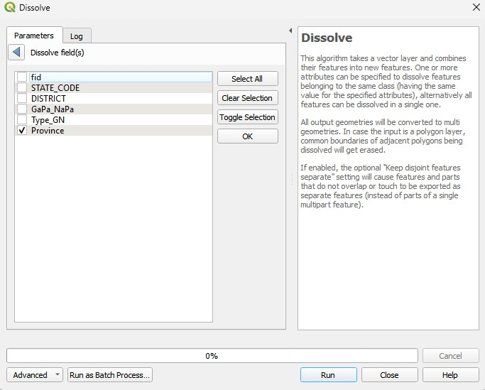

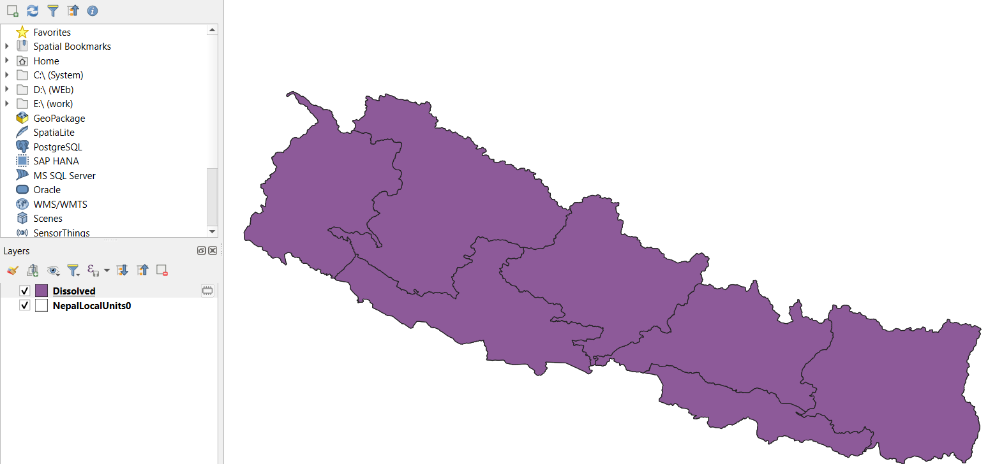

**Step 6:** On the “Processing Toolbox”. Search for “dissolve” under “Vector Geometry”. Click on “Dissolve” option and select dissolve by district.

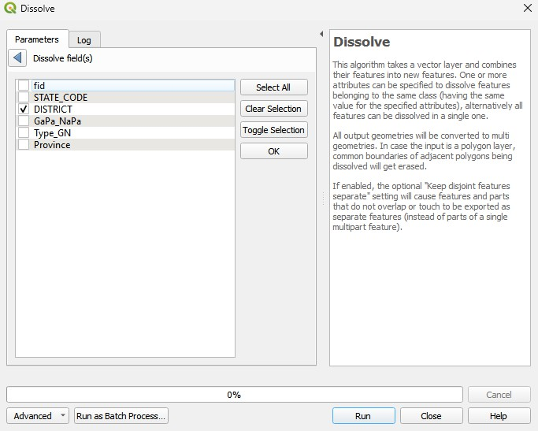

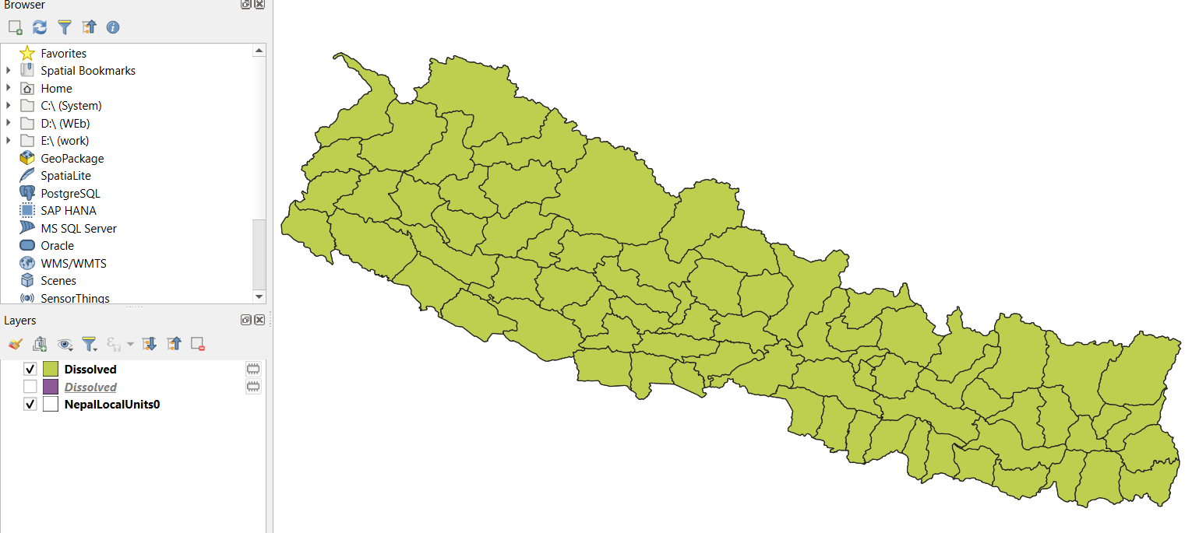

**Step 7:** Now from the layers panel, select Dissolved layers and change the transparency and outline to make province, districts and municipalities distinctive. You can see the following result:

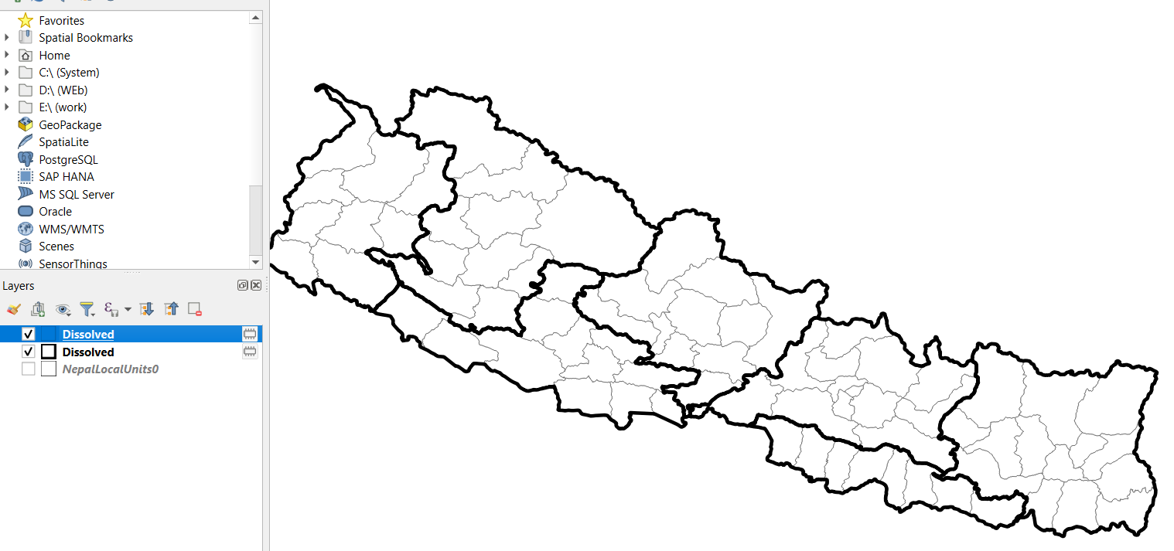

**Step 8:** Now click on project and the on New Print Layout then give a name of the Print Layout

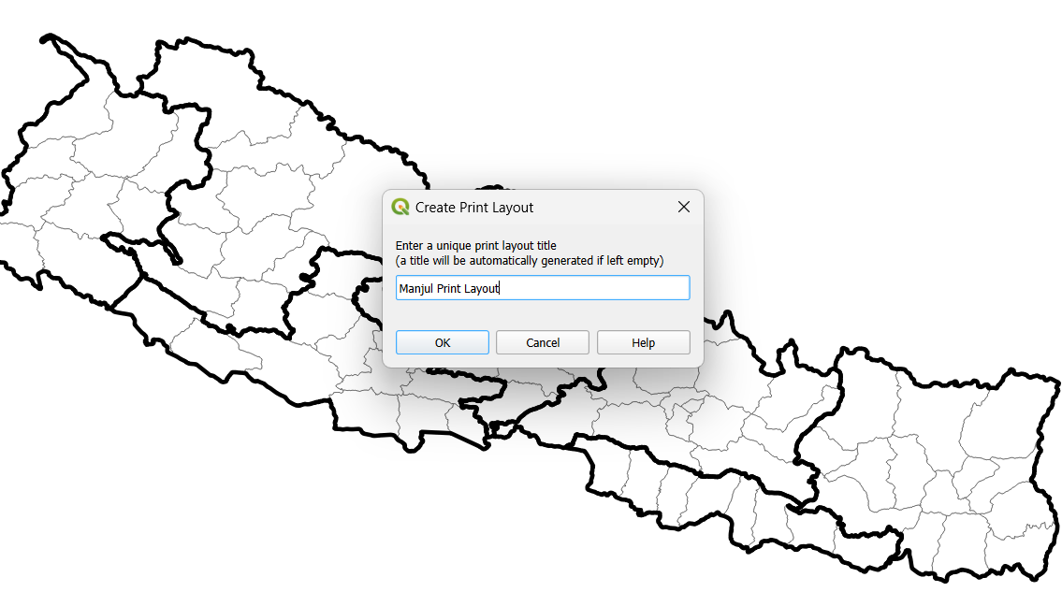

**Step 9:** Add map, legend and North Arrow and then save the map.

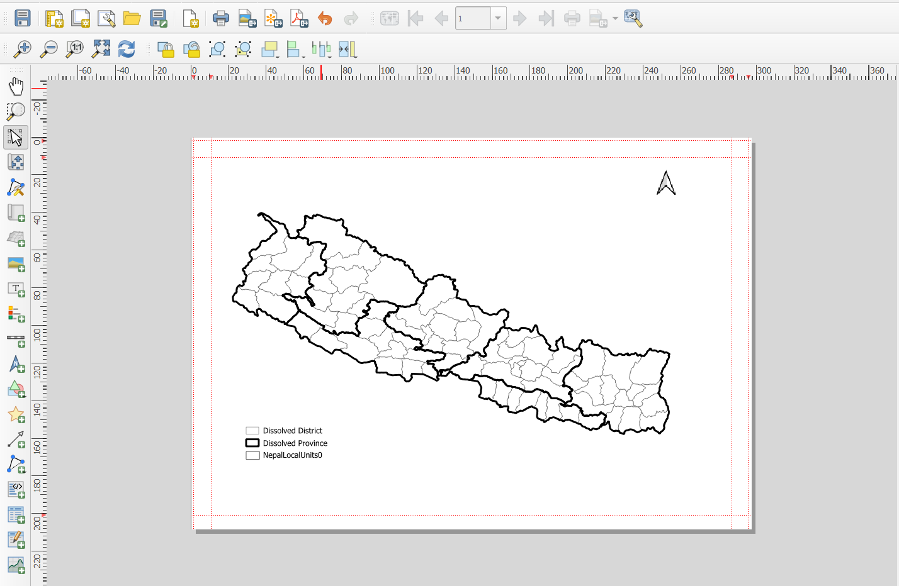

***Practical 5: Mosaicking and Clipping***

**Step 1:** Download all tiles that cover Nepal from the following website: <https://dwtkns.com/srtm30m/>

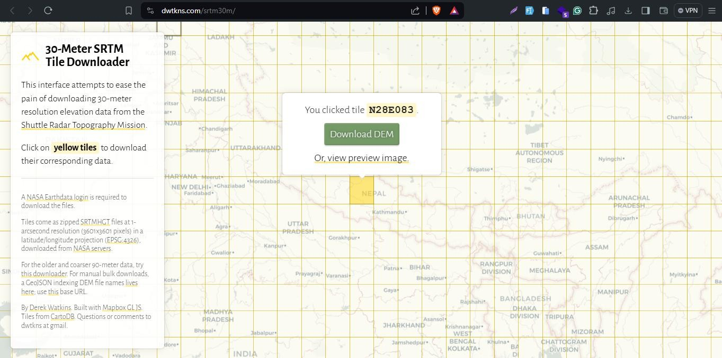

**Step 2:** Load all the dataset to QGIS and make sure that the tiles cover all Nepal

**Step 3:** Load Nepal’s country boundary from already downloaded data.

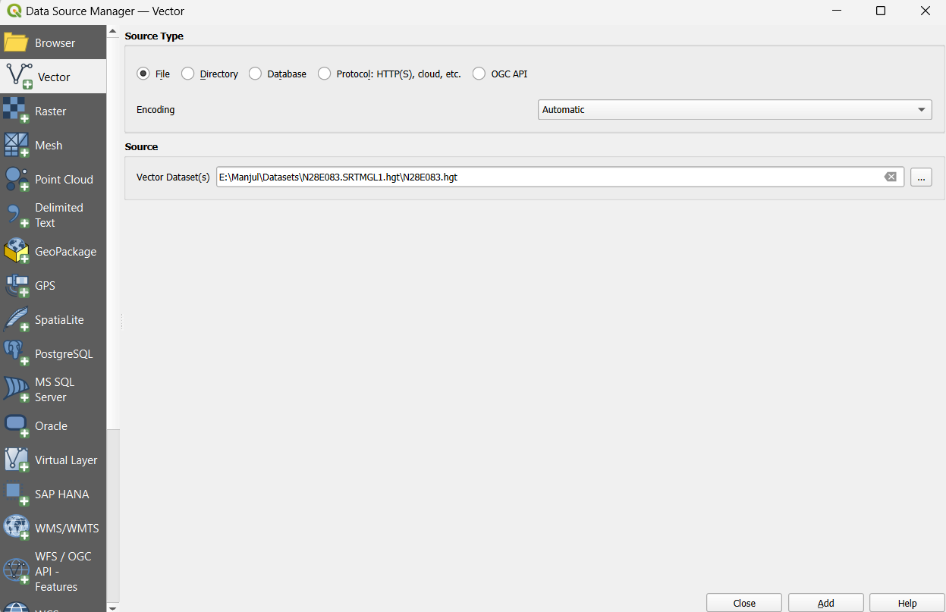

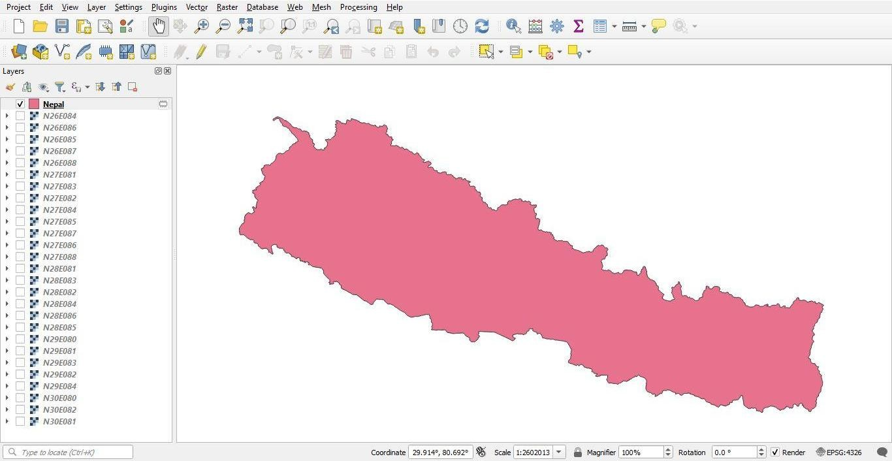

**Step 4:** Goto Raster > Miscellaneous > Merge

* Select all raster and merge them
* This makes individual tiles to become a single raster
* This is termed as mosaicking.

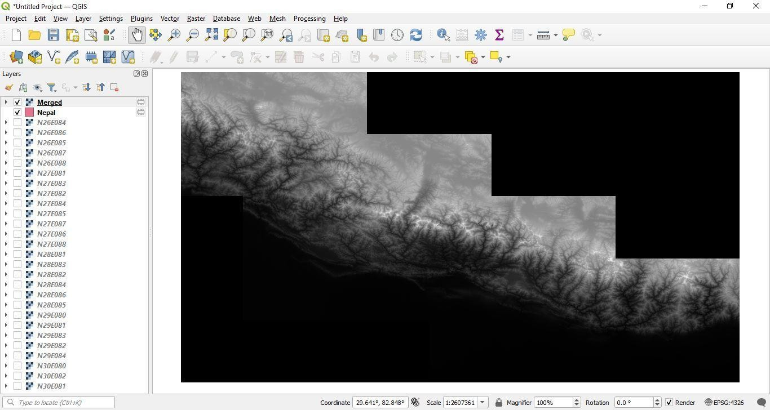

**Step 5:** From the processing toolbox:

* Search for clip
* Find the one that says clip raster mask
* Select the mosaicked raster as raster and map of Nepal as vector

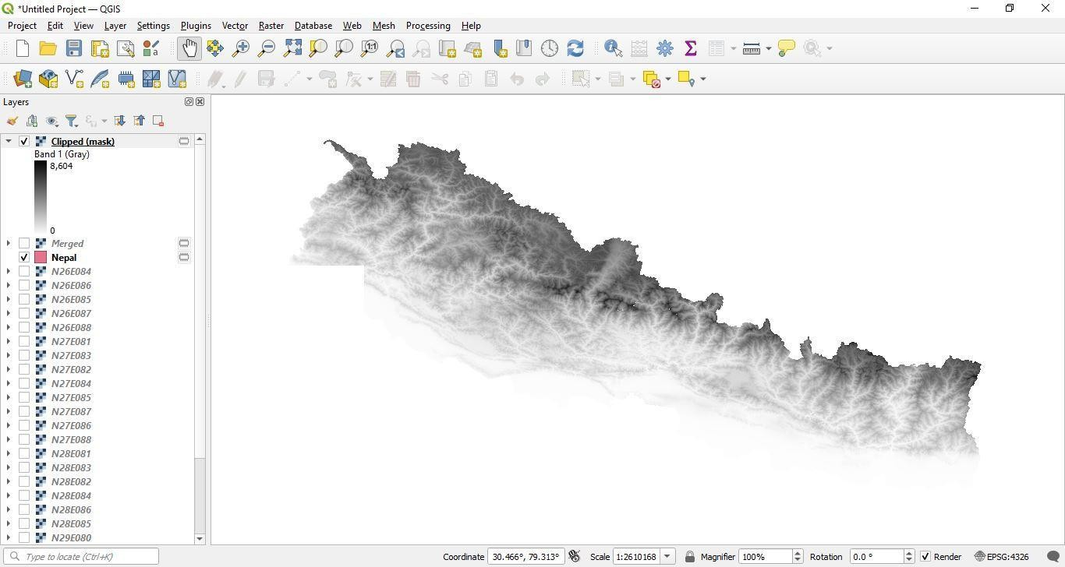

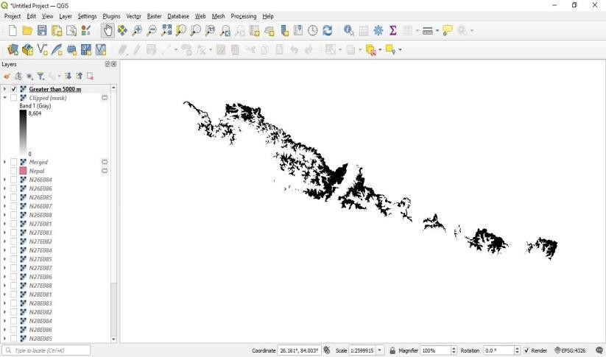

***Practical 6: Geo-referencing Topo Sheet***

**Step 1:** Download a topo sheet of Nepal **Step 2:** Load the topo sheet to QGIS. **Step 3:** Layer > Geo Referencer

* Add the topo sheet to the geo reference.
* Provide at least 3 coordinates for points in the raster
  + Click to a point. Then manually type the coordinates.
* Click ‘Start Geo referencing’ i.e., the play icon.
  + Make note of ‘dX’, ‘dY’ and ‘Residual (pixels)’
  + These are errors in our data.

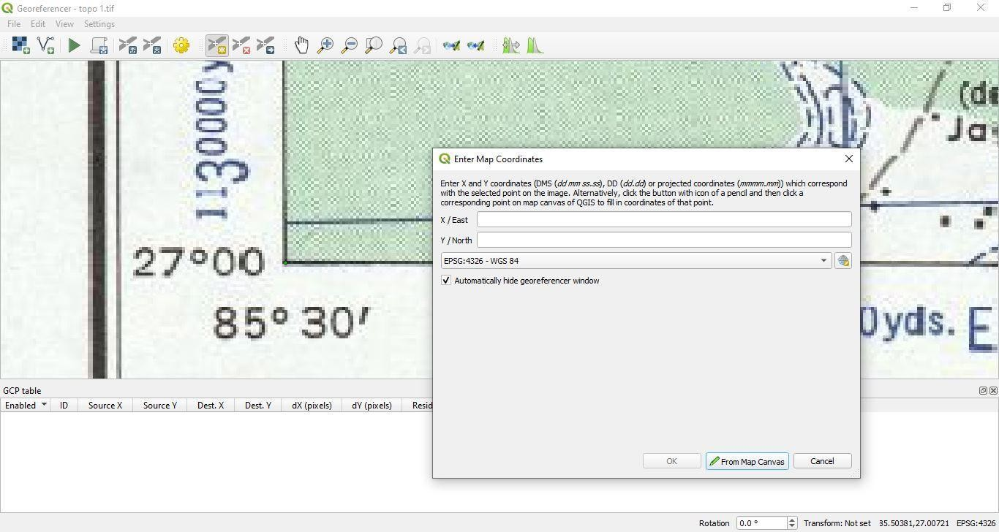

**Step 4:** Add the geo referenced data to QGIS. Make note that all points now have coordinates. That is the data is now geo referenced.

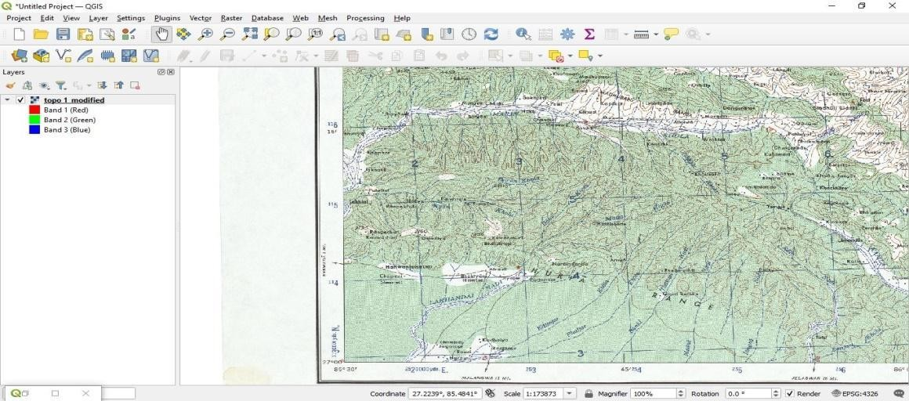

**Step 5:** Overlay with map of Nepal.

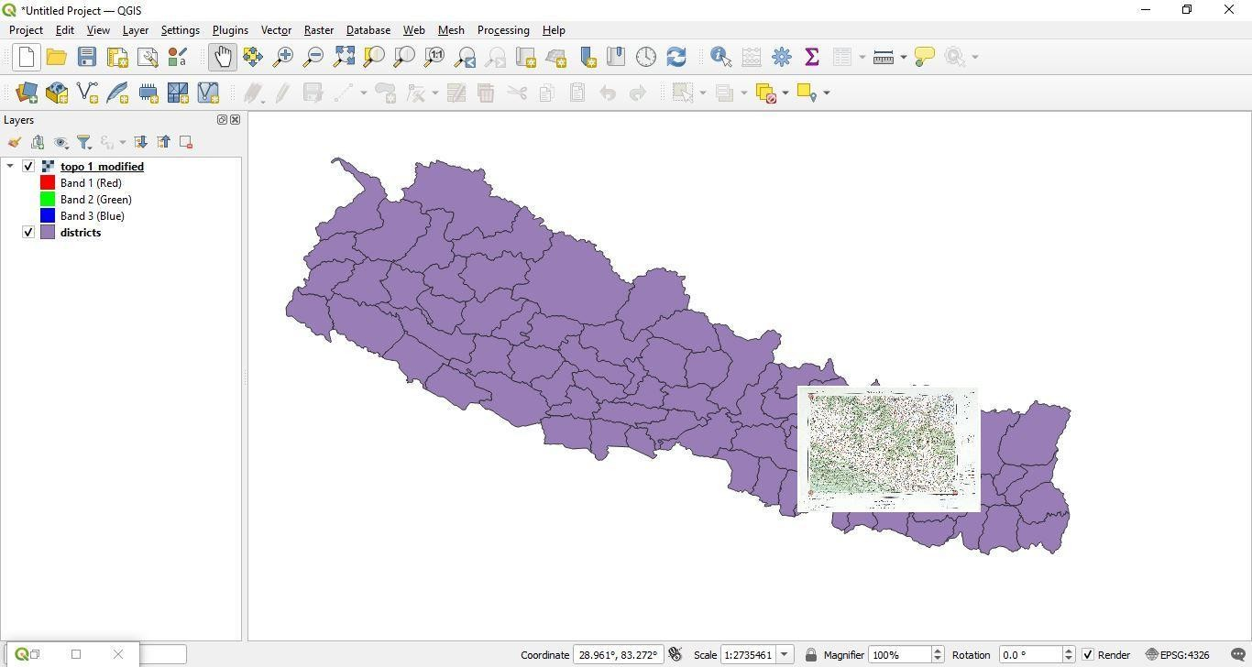

***Practical 7: Vector Analysis: How many buildings in Nepal have road access?***

**Step 1:** Define road Access: For the purposes of this practical, we will assume that any building that is within 1 km of a road has ‘Road Access’

**Step 2:** Download Transportation and Building data from national geoportal

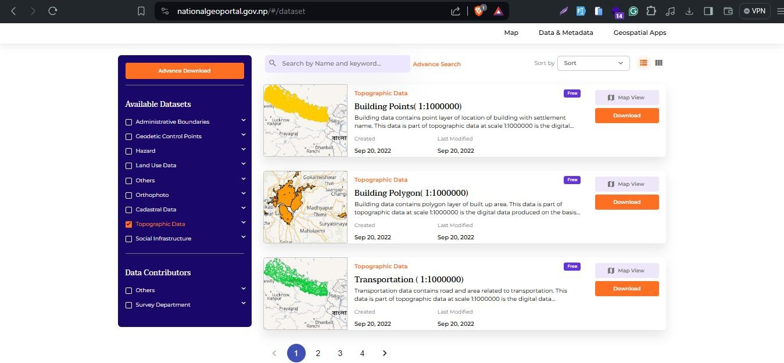

**Step 3:** Load them both to QGIS

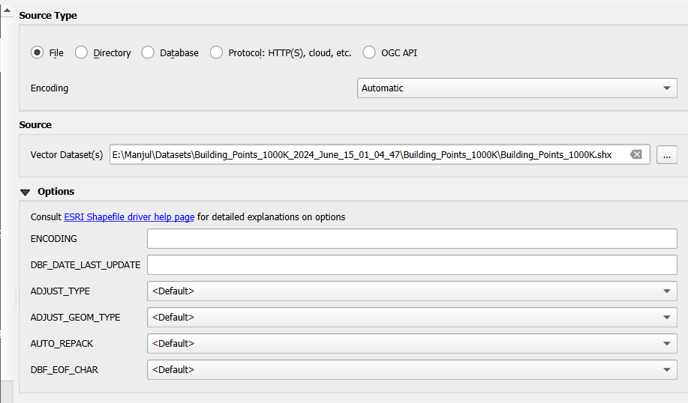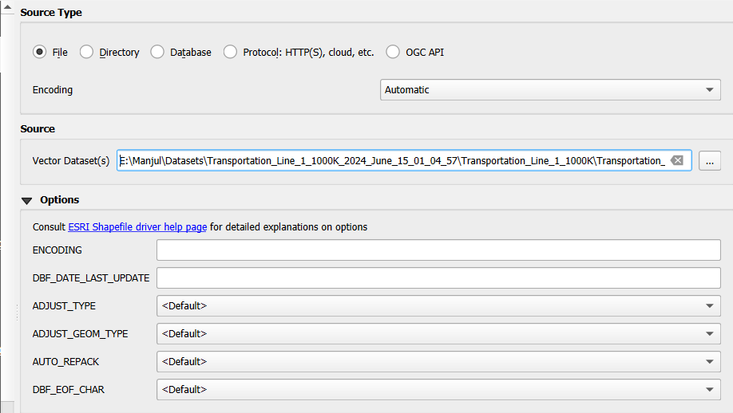

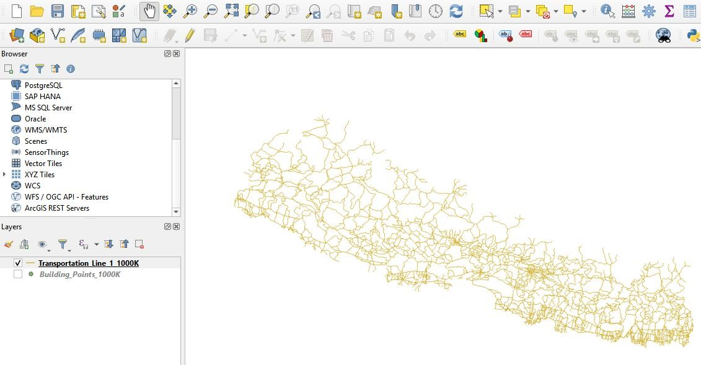

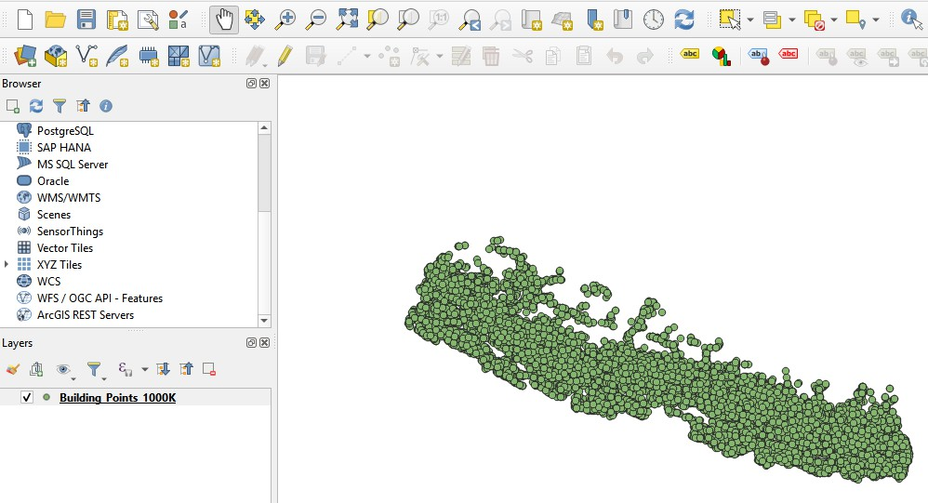

**Step 4:** Reproject both layers to PCS: UTM 45 N

* Search ‘Reproject’ from the geoprocessing Toolbox.
* Make sure to select vector reprojection and NOT raster reprojection.
* Caveat: Nepal utilizes different projection parameters for different regions
* For this practical we will assume that a single projection will have no significant consequences.

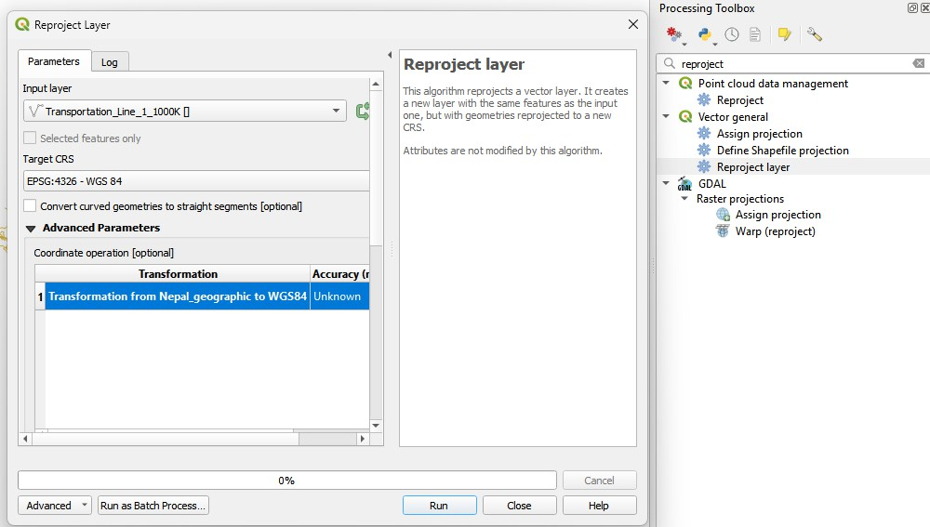

**Step 6:** Buffer the Roads by 1000 m

* Vector > Geoprocessing tools > Buffer
* Type 1000 m in the appropriate area.

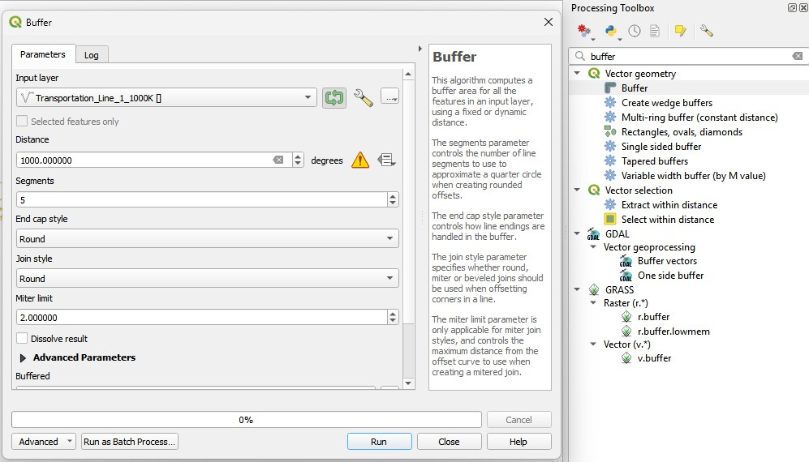

**Step 7:** Selecting by distance

* Vector > Research Tools > Select by distance
* Select from > Buildings
* Within distance from > Roads
* Distance of > 1000 m
* Provide the above parameters and find the total buildings in Nepal that have road access.

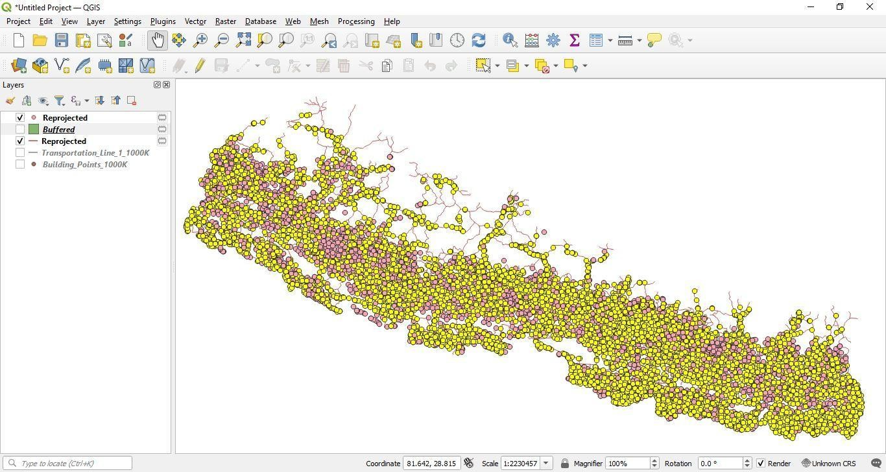

***Practical 8: Vector Analysis: How many buildings are within a given district?***

**Step 1:** Download Building and District data from national geoportal



**Step 2:** Load them both to QGIS

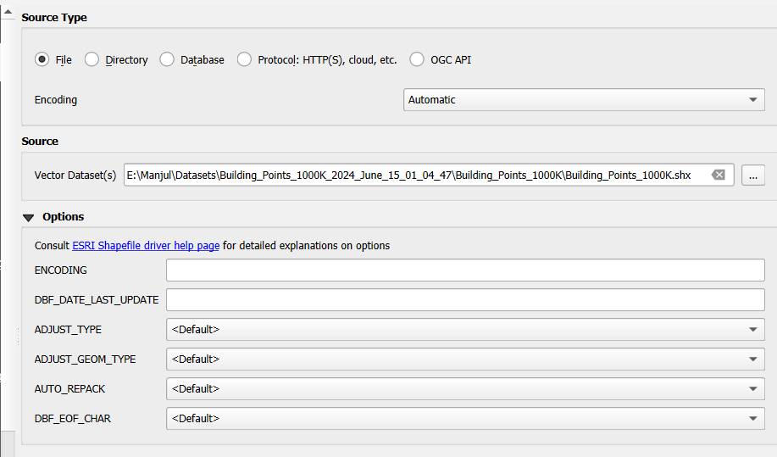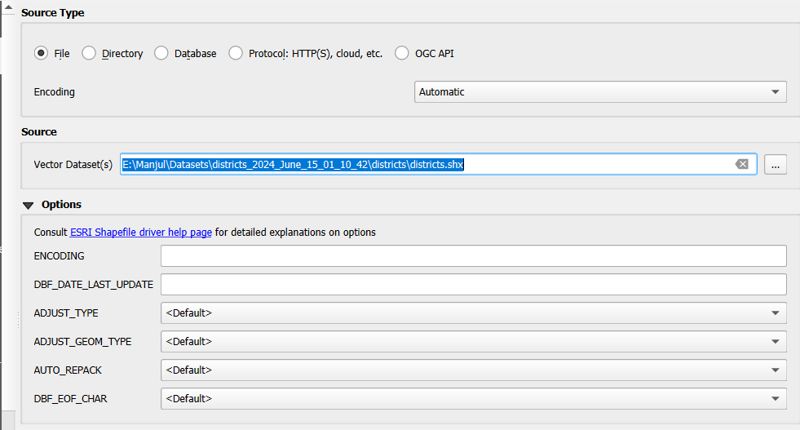

**Step 3:** Vector > Count Points in Polygon

* + Provide Districts Layer as first input
  + Provide Buildings layer as second input and run

**Step 4:** Open Attribute table to find out the number of buildings in each district.

